MZUZU DIOCESE CATHOLIC SECONDARY SCHOOLS
2017 MALAWI SCHOOL CERTIFICATE OF EDUCATION
MOCK EXAMINATION
MATHEMATICS Subject Number: M131/II
Friday, March 31 Time Allowed: 2Hours 30 min
7.30 am – 10.00 am
PAPER II (100 Marks)
Question number | Tick if answered | Do not write in this column
1
2
3
4
5
6
7
8
9
10

11
Total
Instructions
1. This paper contains 18 pages. Please check.
2. Answer all questions in section A and any three
questions from section B.
3. The maximum number of marks for each answer
is indicated against each question.
4. Write your solutions in the spaces provided.
5. Calculators may be used.
6.All working must be clearly shown.
7. Write your name and class at the top of
every page.
8. In the table provided on this page, tick against the
question number you have answered.

2016 MZUZU DIOCESE Turn Over

SECTION A (55 marks)
Instruction
- Answer all the 6 questions in this section

- a) Factorise completely, $x^{4}-16$ 3 marks

- Rationalise the denominator of $\frac{\sqrt{3}}{3\sqrt{5}-2}$ 4 marks

- a) Multiply $\left(\begin{matrix}6 & 3 \\ 2 & 4 \\ 0 & 1\end{matrix}\right)\left(\begin{matrix}2 & 4 \\ 1 & 3\end{matrix}\right)$ 6 marks

b) Solve the following simultaneous equations, $xy=12, y+2x=11$
7 marks

- a) Find a formula for y in terms of x, for the values in the table below.
x | 1 | 2 | 3 | 4 | 5
y | 4 | 7 | 10 | 13 | 16
5 marks

b) An office manager wishes to get some idea as the number of phone calls received by the office during a typical 5 day week. They were as follows:$15, 23, 19, 31, 22$.
Determine the standard deviation of this data. 6 marks

- a) A helicopter is flying above a horizontal ground. Its searchlight is aimed at an angle of depression of $55°$. The beam is shining on the grounds at a point $45 metres$ in front of it. What is the height of the helicopter above the ground? 4 marks

- The function g is given by $g\left(x\right)=ax^{2}-b$. If $g\left(2\right)=5$ and $g\left(-1\right)=2$, find the values of a and b. 5 marks

- a) The remainder when $\left(x+b\right)(x-2b)$ is divided by $(x-b)$is $-32$. Find the value of b. 5 marks

b) Using the figure below,
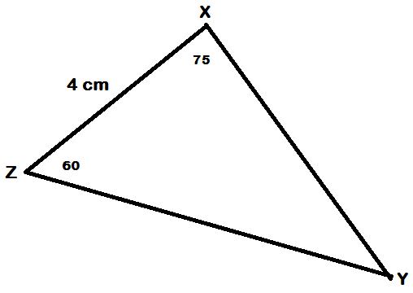

Calculate the length of $XY$, leaving your answer in the simplest surd form.
6 marks

- Without using a calculator, construct in the same diagram
- a triangle PQR with $PR=7cm, PQ=11cm and angle PQR=30°$
- through R, a perpendicular to $QR$, produced if necessary
- a perpendicular bisector of $PR$. Let the perpendiculars meet at I
- a circle which passes through P and R and has PR as the tangent at R
- measure and state the radius of the circle 6 marks

SECTION B (45 marks)
- Answer any 3 questions from this section

- a) Show that the points $A\left(-4, 3\right), B(-1, 5)$ and $C(8, 11)$ are collinear. 6 marks

b) If $y$varies partly with $x$ and partly with $z^{2}$, and $y=2$ when $x=4$ and $z=2$, and $y=43$ when$x=2$ and $z=4$, find:
- a formula giving y in terms of x and z 6 marks

- the value of y when $x=\frac{1}{2}$ and $z=\frac{1}{2}$ 3 marks

- a) A ship sails from port A for $35km$ on a bearing of $120°$ and then $54km$on a bearing of $250°$. How far is it from the port now to the nearest kilometer? 7 marks

b) i) complete the table of values of the function $y=2x^{2}-3$
x | -2 | -1 | 0 | 1 | 2
y |  | -1 | -3 |  | 5

ii) plot a graph of the function taking $2cm$ to represent $1 unit$ on both the x-axis and y-axis
iii) use the graph to solve the equation, $2x^{2}-2x-1=0$ 8 marks

- a) C is the centre of the large circle and O is the centre of the small circle. PT is a tangent to the small circle and PCAOB is a straight line. The small circle has a radius of $1cm$.

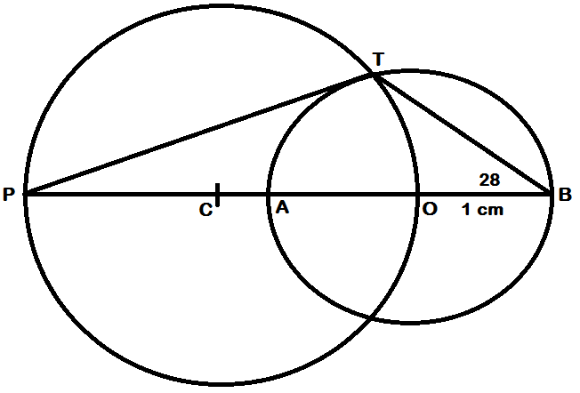
Calculate the radius of the large circle. 7 marks

- Solve for x in the following equation, $5^{2x+1}+5=26×5^{x}$
- Marks

- a) Given that $a=\left({5 \atop 9}\right) and b=\left({3 \atop -3}\right),$ find the magnitude of $\left|a-b\right|$
5 marks

b) Lisa has a jewelry shop where she sells earrings and necklaces. She sells earrings for K30 and necklaces for K40. It takes 30 minutes to make a pair of earrings and 1 hour to make a necklace, and Lisa has only 10 hours a week to make jewelry. In addition, she only has enough materials to make 15 total jewelry items per week. She makes a profit of K15 on each pair of earrings and K20 on each necklace.
- Taking x to represent the number of pairs of earrings and y to represent the number of necklaces, write down two inequalities, in addition to $x≥0$ and $y≥0$, that satisfy the above information.
- Using a scale of 2 cm to represent 5 units on both axes, draw graphs to show the region bounded by the inequalities, and shade the unwanted region.
- Use the graph to find how many pairs of earrings and how many necklaces should Lisa make in a week to make the biggest profit.
10 marks

- a) Find the sum of the first ten terms of a geometric progression that has a sixth term of $\frac{32}{33}$ and a seventh term of $1\frac{31}{33}$. 7 marks

- Figure below is a triangular prism, whose rectangular base measures $5 cm by 9 cm$while the height is $6 cm$.
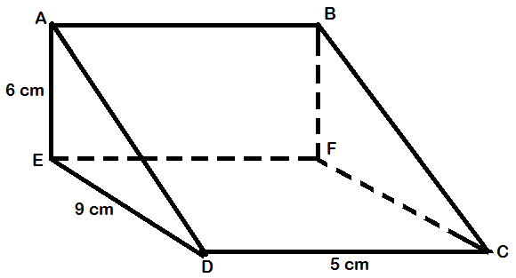
Calculate
- the length of $AC$
- the angle $AC$makes with the plane $CDEF$
8 marks

END OF QUESTION PAPER

